Day 2 : Basic Linux commands

This is **#90DaysofDevops** challenge under the guidance of [ShubhamLondhe](https://www.linkedin.com/in/shubhamlondhe1996/) sir

Task: What is the linux command to

1. Check your present working directory.
2. List all the files or directories including hidden files.
3. Create a nested directory A/B/C/D/E

**What is the linux ?**

* Linux is a free and open-source operating system (OS) that was created by Linus Torvalds in 1991. It is based on the Unix operating system.
* Linux is known for its stability, security, and flexibility
* There are many different distributions of linux. Some of the most popular distributions includes Ubuntu, CentOs, Feroda, Red Hat, Linux Mint.

1. **Check your present working directory.**

The “pwd” command stands for “**print working directory**”. This command is use to print the full path of current working directory.

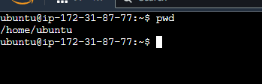

1. **List all the files or directories including hidden files**.

The “ls” command is use to list all the sub directory and files available in present working directory.

“-a” option is tells the “ls” to list all including hidden files and directory.

“-l” option is tells the “ls” to list the files and directories in long list format with extra information

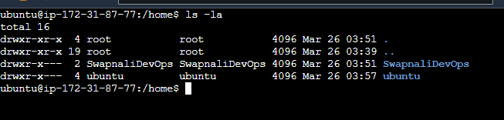

1. **Create a nested directory A/B/C/D/E**

The command to create a nested directory is **mkdir** -p A/B/C/D/E.

The “-p” is used to creates parents’ directories

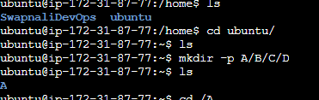

**Thank you for reading….**

**-Swapnali.**